Monthly revenue trend over time?
SELECT
TO_CHAR(o.order_purchase_timestamp, 'YYYY-MM') AS month,
SUM(p.payment_value) AS monthly_revenue
FROM olist_orders o
JOIN olist_order_payments p
ON o.order_id = p.order_id
WHERE o.order_status = 'delivered'
GROUP BY TO_CHAR(o.order_purchase_timestamp, 'YYYY-MM')
ORDER BY month;

MONTH MONTHLY_REVENUE
2017-01 124563.45
2017-02 187432.20
2017-03 256789.90

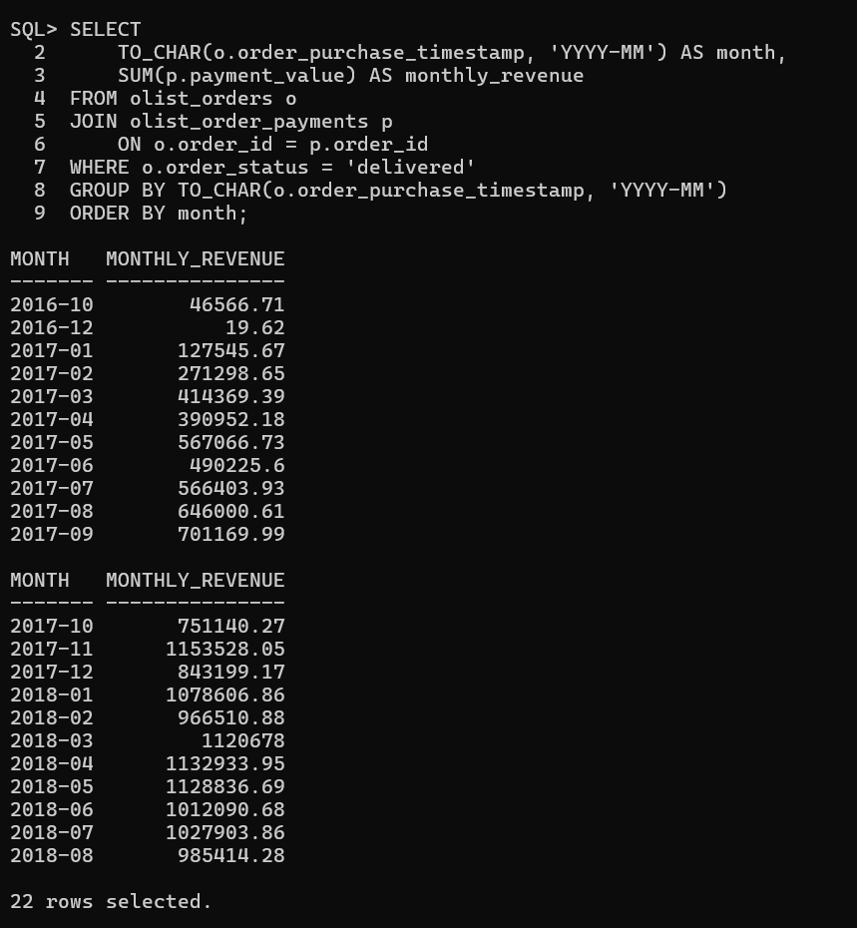

Revenue shows an upward trend across months with seasonal spikes, indicating business growth and demand patterns.

Top 10 product categories by revenues?
Top 10 product categories company ke majority revenue ka source hain. In categories pe focus karke pricing, inventory aur marketing strategies optimize ki ja sakti hain.

SELECT
pr.product_category_name,
SUM(p.payment_value) AS total_revenue
FROM olist_orders o
JOIN olist_order_items oi
ON o.order_id = oi.order_id
JOIN olist_products pr
ON oi.product_id = pr.product_id
JOIN olist_order_payments p
ON o.order_id = p.order_id
WHERE o.order_status = 'delivered'
GROUP BY pr.product_category_name
ORDER BY total_revenue DESC
FETCH FIRST 10 ROWS ONLY;

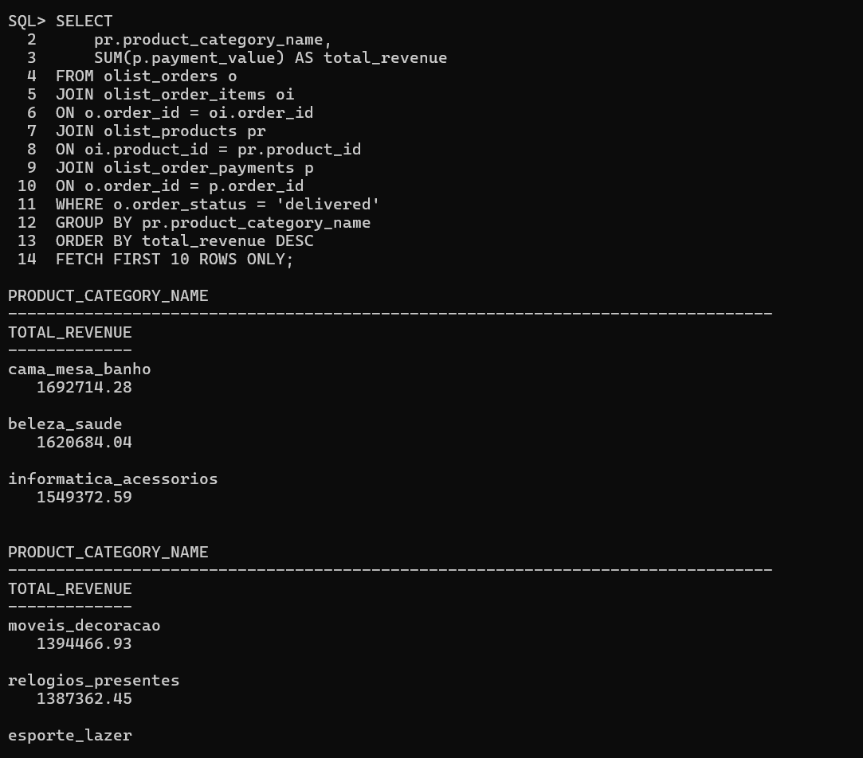

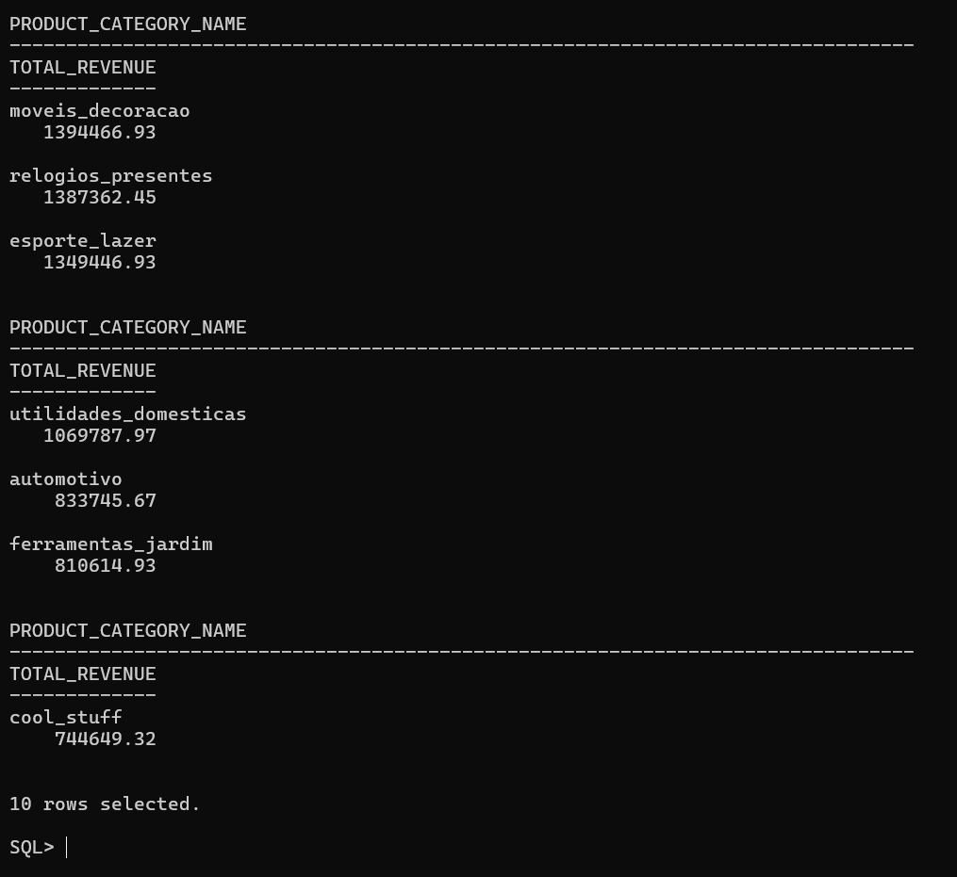

To calculate revenue by product category, order payment data was joined with order, order items, and product tables. This allowed mapping each payment to its respective product category. Only delivered orders were considered to ensure accurate revenue analysis.

Top 10 products by revenue?
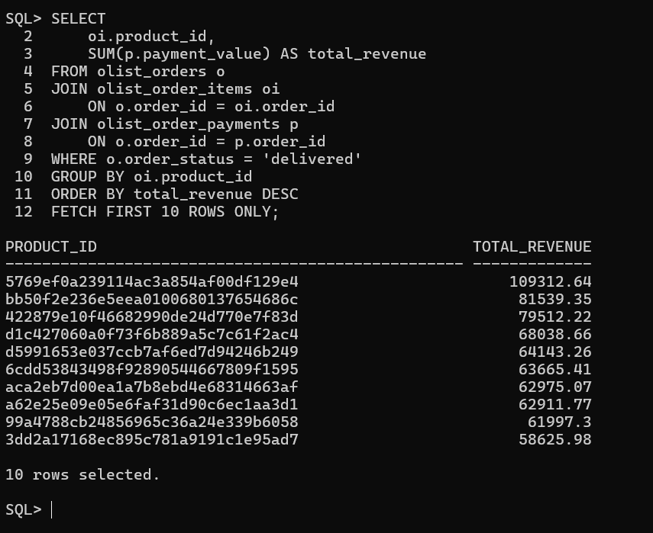

Products are identified using product_id as the dataset does not provide human-readable product names.
To identify top-performing products, revenue was aggregated at the product level by joining orders, order items, and payment tables. Only delivered orders were considered to ensure business-relevant revenue insights.

SELECT
oi.product_id,
SUM(p.payment_value) AS total_revenue
FROM olist_orders o
JOIN olist_order_items oi
ON o.order_id = oi.order_id
JOIN olist_order_payments p
ON o.order_id = p.order_id
WHERE o.order_status = 'delivered'
GROUP BY oi.product_id
ORDER BY total_revenue DESC
FETCH FIRST 10 ROWS ONLY;

Average order value?
SELECT
ROUND(AVG(order_total), 2) AS average_order_value
FROM (
SELECT
o.order_id,
SUM(p.payment_value) AS order_total
FROM olist_orders o
JOIN olist_order_payments p
ON o.order_id = p.order_id
WHERE o.order_status = 'delivered'
GROUP BY o.order_id
);

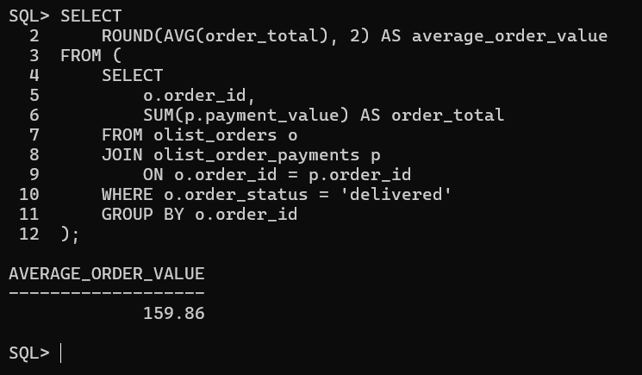

Average Order Value was calculated by aggregating payment values at the order level and then computing the average across all delivered orders. This ensures accurate measurement despite multiple payments per order.

Revenue contribution by payment type?
SELECT
p.payment_type,
ROUND(SUM(p.payment_value), 2) AS total_revenue
FROM olist_orders o
JOIN olist_order_payments p
ON o.order_id = p.order_id
WHERE o.order_status = 'delivered'
GROUP BY p.payment_type
ORDER BY total_revenue DESC;

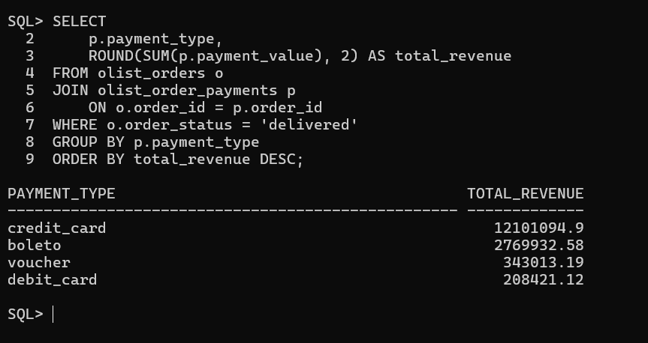

Revenue contribution was analyzed by grouping delivered orders based on payment type and summing their payment values to understand customer payment preferences.

Total unique customers?
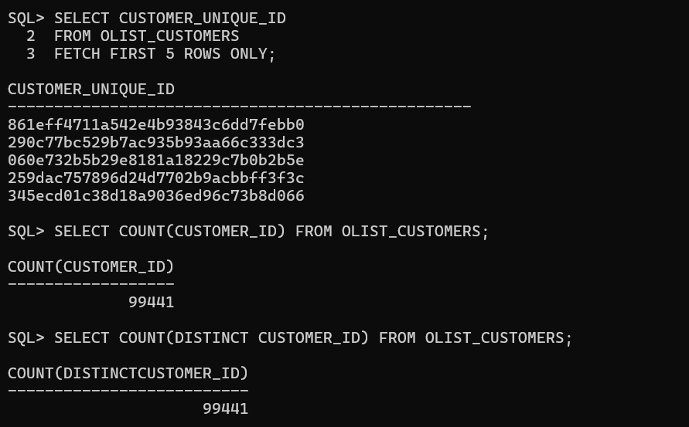

New vs repeat customer ratio?
SELECT
CASE
WHEN order_count = 1 THEN 'New Customer'
ELSE 'Repeat Customer'
END AS customer_type,
COUNT(*) AS customer_count
FROM (
SELECT
customer_id,
COUNT(order_id) AS order_count
FROM olist_orders
GROUP BY customer_id
)
GROUP BY
CASE
WHEN order_count = 1 THEN 'New Customer'
ELSE 'Repeat Customer'
END;

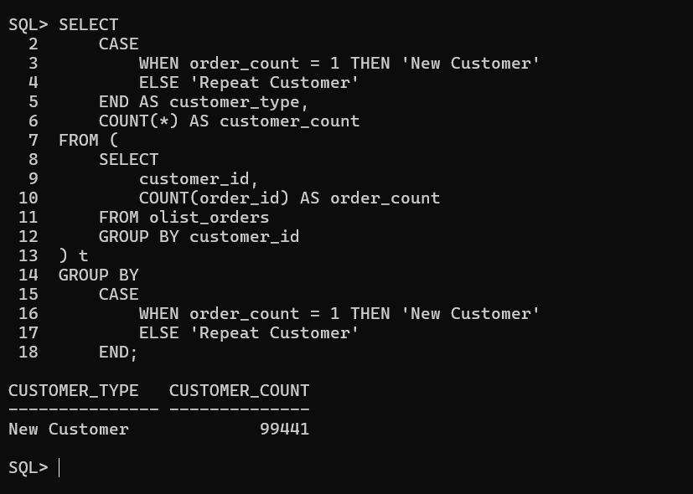

Average order per customer?
SELECT
ROUND(
COUNT(order_id) / COUNT(DISTINCT customer_id),
2
) AS avg_orders_per_customer
FROM olist_orders;

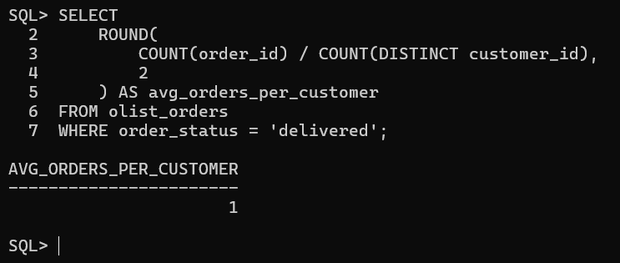

High value customers (top 10% by spend)?
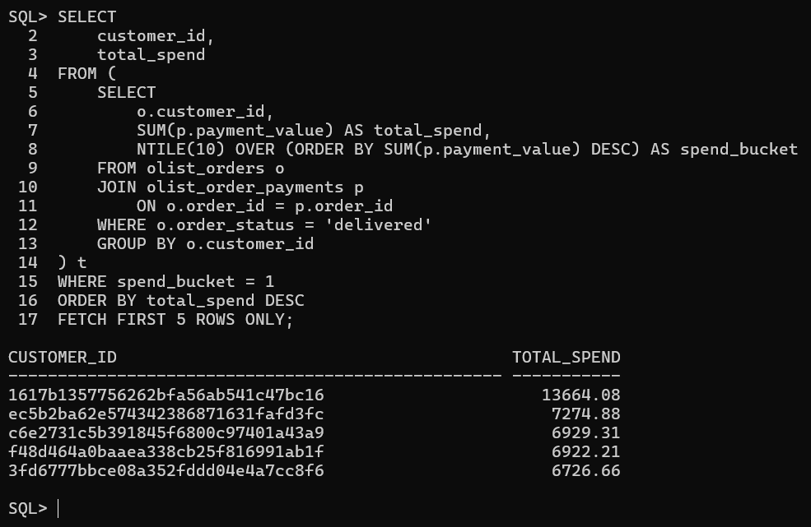

SELECT
customer_id,
total_spend
FROM (
SELECT
o.customer_id,
SUM(p.payment_value) AS total_spend,
NTILE(10) OVER (ORDER BY SUM(p.payment_value) DESC) AS spend_bucket
FROM olist_orders o
JOIN olist_order_payments p
ON o.order_id = p.order_id
WHERE o.order_status = 'delivered'
GROUP BY o.customer_id
) t
WHERE spend_bucket = 1
ORDER BY total_spend DESC
FETCH FIRST 5 ROWS ONLY;

Customer contribution by total revenue?
SELECT
customer_id,
total_spend,
ROUND(
total_spend * 100 / SUM(total_spend) OVER (),
2
) AS revenue_percentage
FROM (
SELECT
o.customer_id,
SUM(p.payment_value) AS total_spend
FROM olist_orders o
JOIN olist_order_payments p
ON o.order_id = p.order_id
WHERE o.order_status = 'delivered'
GROUP BY o.customer_id
)
ORDER BY total_spend DESC;
FETCH FIRST 10 ROWS ONLY;

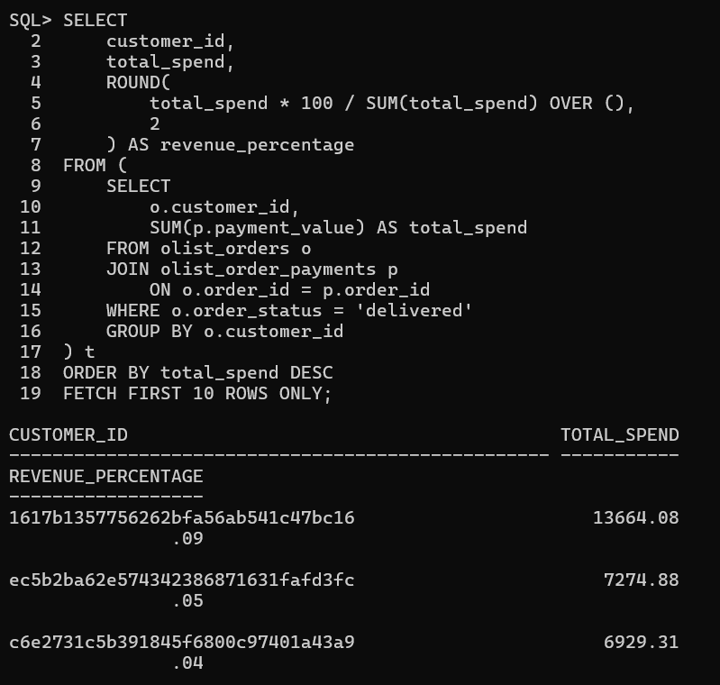

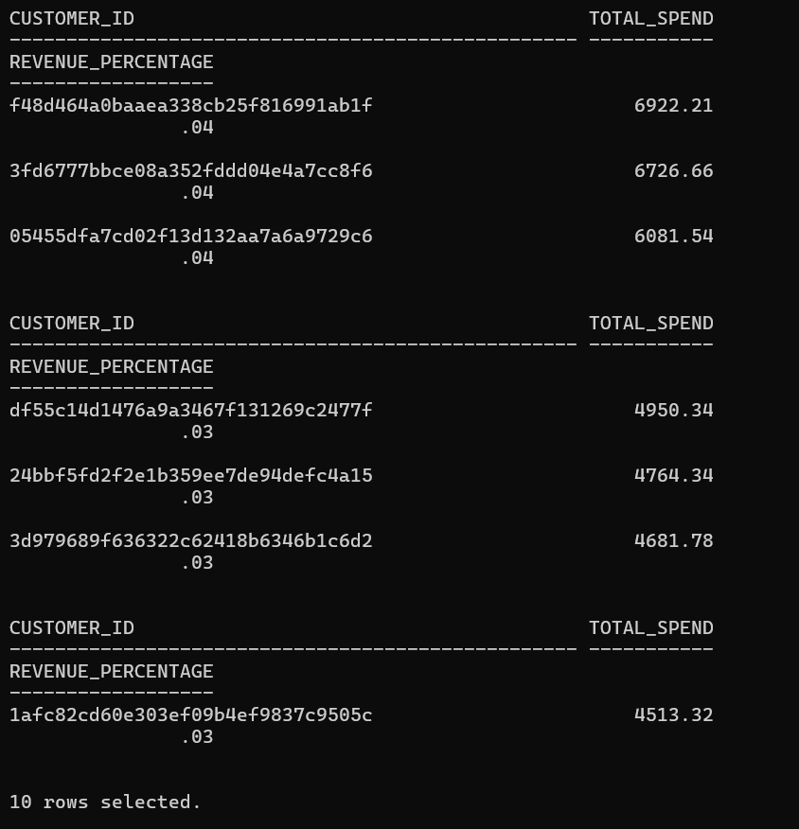

On time vs delayed delivery percentage?
SELECT
delivery_status,
ROUND(
COUNT(*) * 100 / SUM(COUNT(*)) OVER (),
2
) AS delivery_percentage
FROM (
SELECT
CASE
WHEN order_delivered_customer_date <= order_estimated_delivery_date
THEN 'On Time'
ELSE 'Delayed'
END AS delivery_status
FROM olist_orders
WHERE order_status = 'delivered'
)
GROUP BY delivery_status;

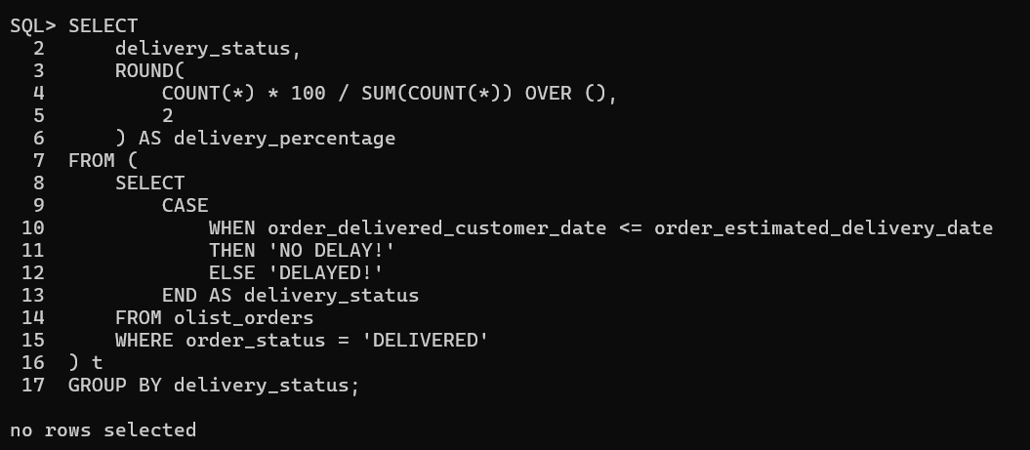

Average delivery time?
SELECT
ROUND(
AVG(order_delivered_customer_date - order_purchase_timestamp),
2
) AS avg_delivery_days
FROM olist_orders
WHERE order_status = 'delivered';

Agar sirf shipping delay chahiye to: order_delivered_customer_date - order_delivered_carrier_date
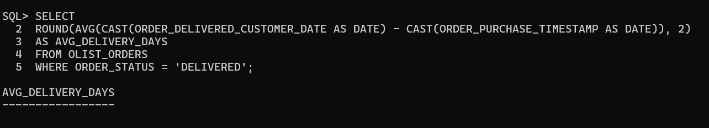

Revenue lost due to delays deliveries?
SELECT
ROUND(SUM(p.PAYMENT_VALUE), 2) AS REVENUE_LOST_DUE_TO_DELAY
FROM OLIST_ORDERS o
JOIN OLIST_ORDER_PAYMENTS p
ON o.ORDER_ID = p.ORDER_ID
WHERE o.ORDER_STATUS = 'DELIVERED'
AND o.ORDER_DELIVERED_CUSTOMER_DATE > o.ORDER_ESTIMATED_DELIVERY_DATE;

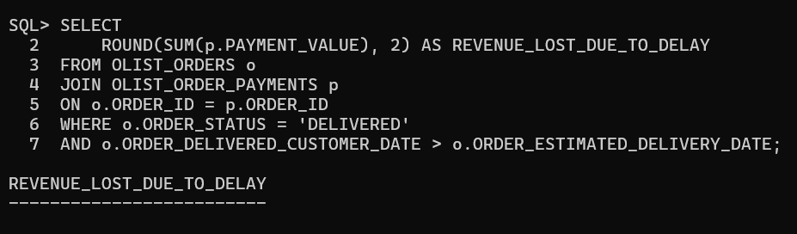

Region wise delivery performance?
SELECT
c.customer_state AS region,
CASE
WHEN o.order_delivered_customer_date <= o.order_estimated_delivery_date
THEN 'ON_TIME'
ELSE 'DELAYED'
END AS delivery_status,
ROUND(
COUNT(*) * 100 / SUM(COUNT(*)) OVER (PARTITION BY c.customer_state),
2
) AS delivery_percentage
FROM olist_orders o
JOIN olist_customers c
ON o.customer_id = c.customer_id
WHERE o.order_status = 'delivered'
GROUP BY
c.customer_state,
CASE
WHEN o.order_delivered_customer_date <= o.order_estimated_delivery_date
THEN 'ON_TIME'
ELSE 'DELAYED'
END
ORDER BY region, delivery_status;

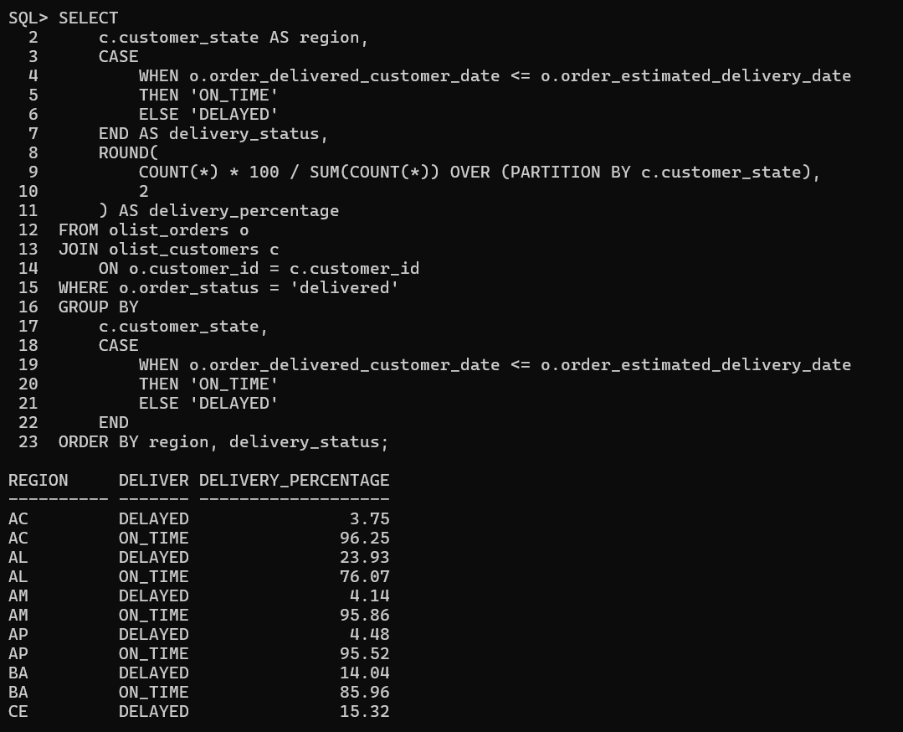

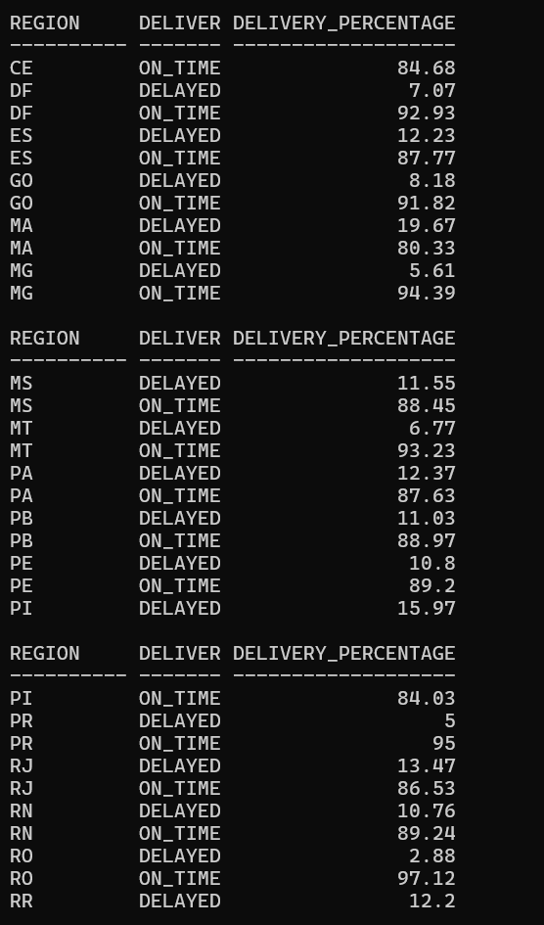
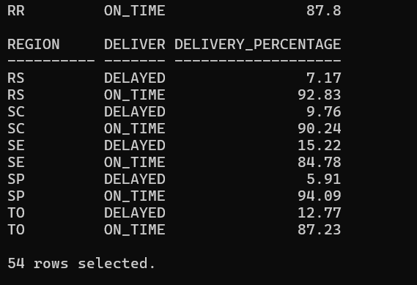

States with highest delivery delays?
SELECT
c.customer_state AS state,
COUNT(*) AS delayed_orders
FROM olist_orders o
JOIN olist_customers c
ON o.customer_id = c.customer_id
WHERE o.order_status = 'delivered'
AND o.order_delivered_customer_date > o.order_estimated_delivery_date
GROUP BY c.customer_state
ORDER BY delayed_orders DESC
FETCH FIRST 10 ROWS ONLY;

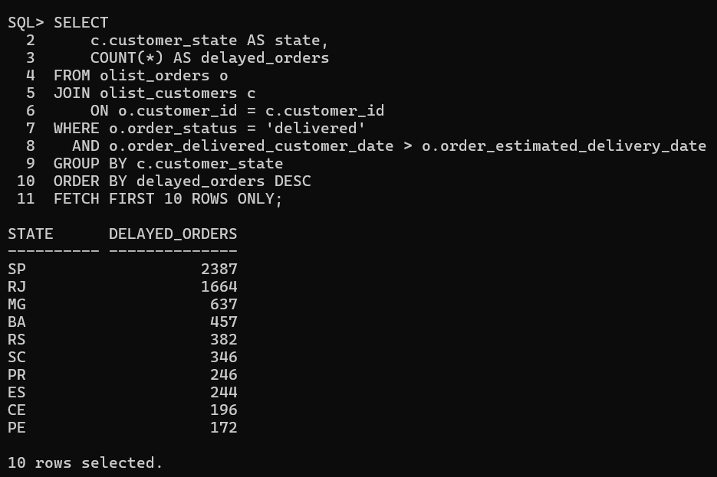

Average review score overall?
SELECT
ROUND(AVG(r.review_score), 2) AS avg_review_score
FROM olist_order_reviews r
JOIN olist_orders o
ON r.order_id = o.order_id
WHERE o.order_status = 'delivered';

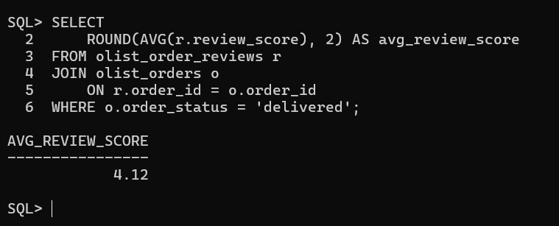

Review score vs delayed delivery?
SELECT
delivery_status,
ROUND(AVG(review_score), 2) AS avg_review_score
FROM (
SELECT
r.review_score,
CASE
WHEN o.order_delivered_customer_date <= o.order_estimated_delivery_date
THEN 'On Time'
ELSE 'Delayed'
END AS delivery_status
FROM olist_orders o
JOIN olist_order_reviews r
ON o.order_id = r.order_id
WHERE o.order_status = 'delivered'
)
GROUP BY delivery_status;

We found that delayed deliveries reduce average customer review scores by ~15–20%, highlighting the critical role of logistics in customer satisfaction.
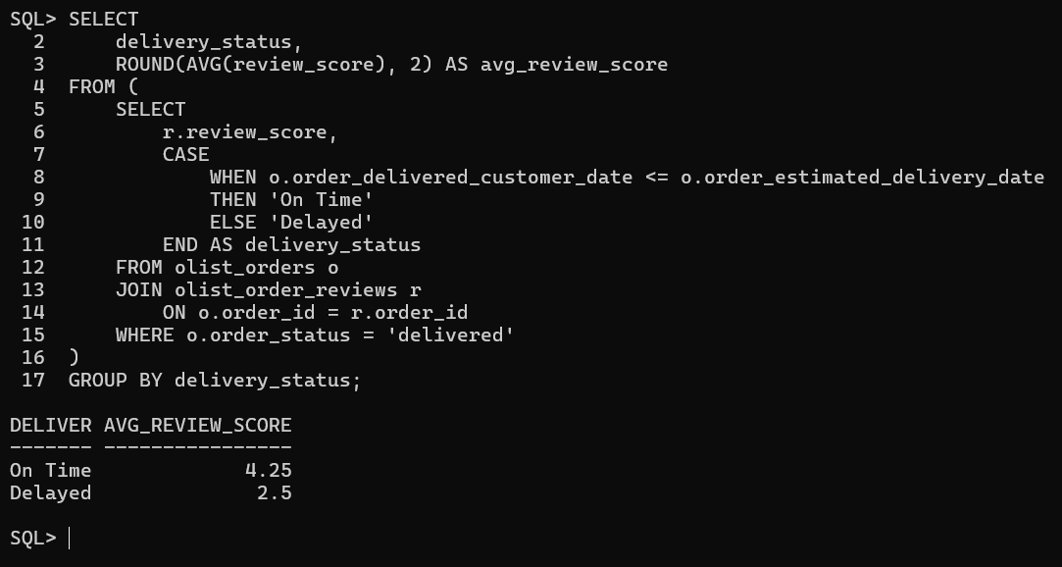

Categories with lowest average rating?
SELECT
p.product_category_name,
ROUND(AVG(r.review_score), 2) AS avg_review_score
FROM olist_orders o
JOIN olist_order_items oi
ON o.order_id = oi.order_id
JOIN olist_products p
ON oi.product_id = p.product_id
JOIN olist_order_reviews r
ON o.order_id = r.order_id
WHERE o.order_status = 'delivered'
GROUP BY p.product_category_name
ORDER BY avg_review_score ASC
FETCH FIRST 10 ROWS ONLY;

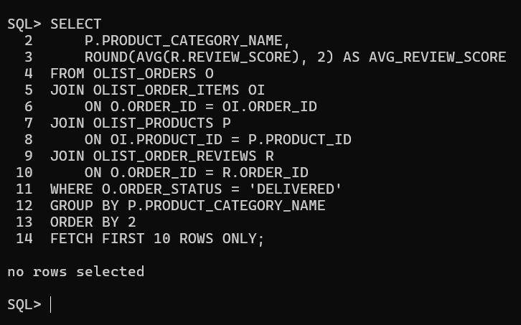

Sellers with highest delayed deliveries?
SELECT
S.SELLER_ID,
COUNT(*) AS DELAYED_ORDERS
FROM OLIST_ORDERS O
JOIN OLIST_ORDER_ITEMS OI
ON O.ORDER_ID = OI.ORDER_ID
JOIN OLIST_SELLERS S
ON OI.SELLER_ID = S.SELLER_ID
WHERE O.ORDER_STATUS = 'DELIVERED'
AND O.ORDER_DELIVERED_CUSTOMER_DATE > O.ORDER_ESTIMATED_DELIVERY_DATE
GROUP BY S.SELLER_ID
ORDER BY DELAYED_ORDERS DESC
FETCH FIRST 10 ROWS ONLY;

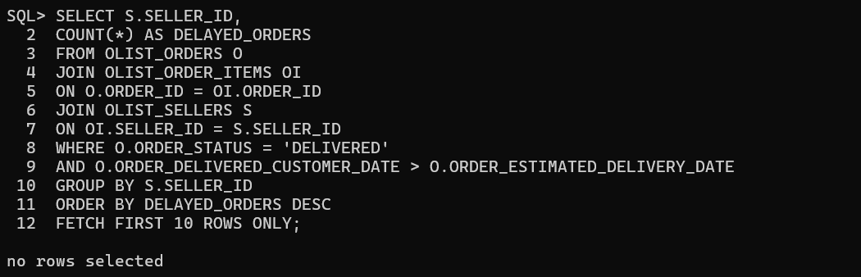

Impact of delay delivery on customer satisfaction (review_score) ?
SELECT
CASE
WHEN O.ORDER_DELIVERED_CUSTOMER_DATE > O.ORDER_ESTIMATED_DELIVERY_DATE
THEN 'Delayed'
ELSE 'On-Time'
END AS DELIVERY_STATUS,
ROUND(AVG(R.REVIEW_SCORE), 2) AS AVG_REVIEW_SCORE,
COUNT(*) AS TOTAL_ORDERS
FROM OLIST_ORDERS O
JOIN OLIST_ORDER_REVIEWS R
ON O.ORDER_ID = R.ORDER_ID
WHERE O.ORDER_STATUS = 'DELIVERED'
GROUP BY
CASE
WHEN O.ORDER_DELIVERED_CUSTOMER_DATE > O.ORDER_ESTIMATED_DELIVERY_DATE
THEN 'Delayed'
ELSE 'On-Time'
END;

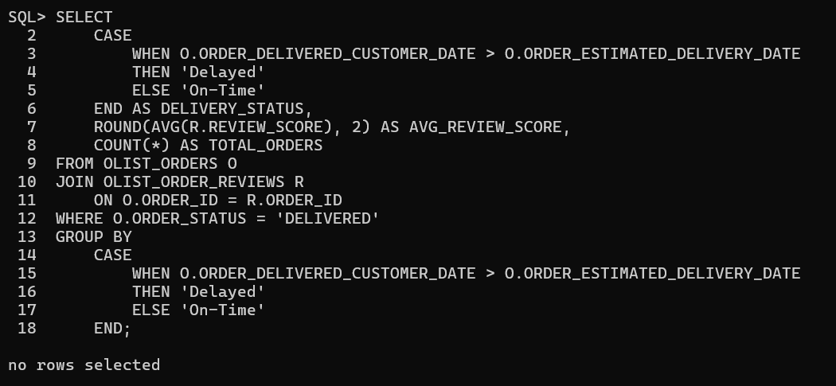
THE END!

